**Prabhat Portfolio**

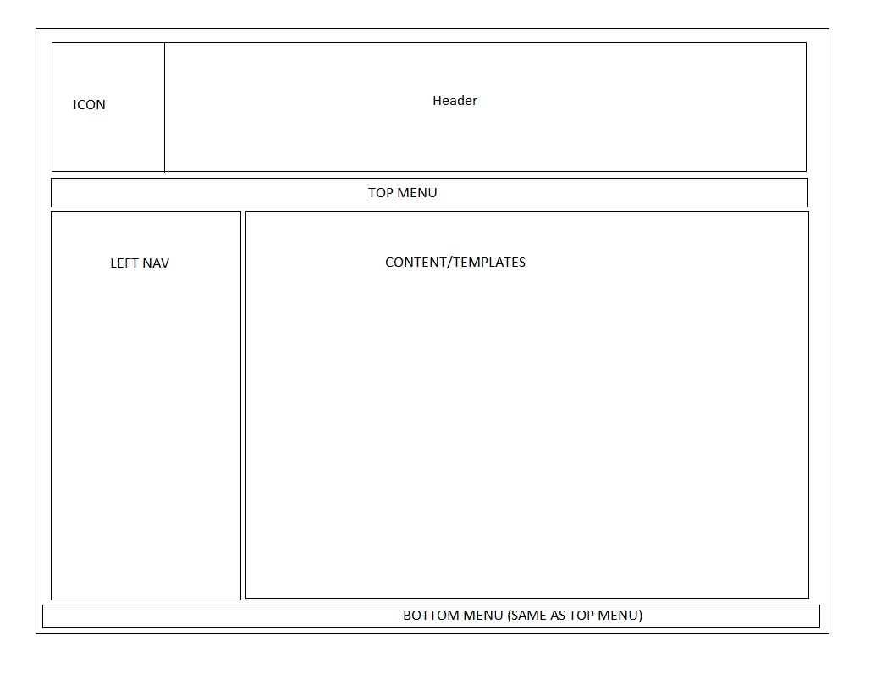

**Templates**

1. Financial domain
2. Health domain
3. Sales domain
4. Mobile domain
5. TBD

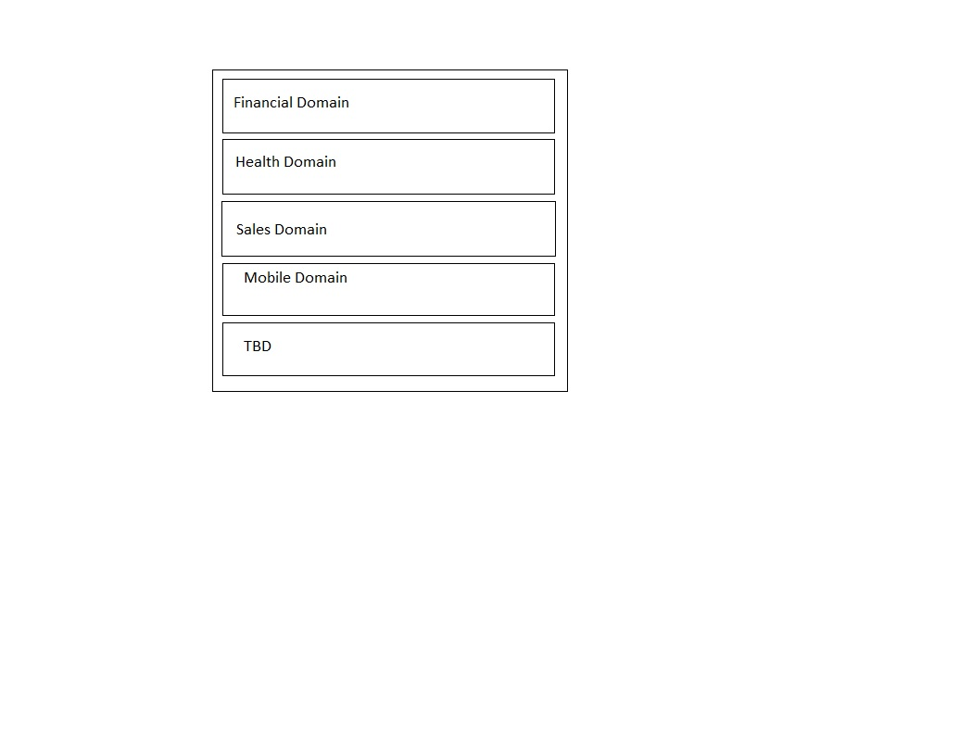

**Financial domain**

Initial 2 buttons

1. Home mortgage
2. Car loan

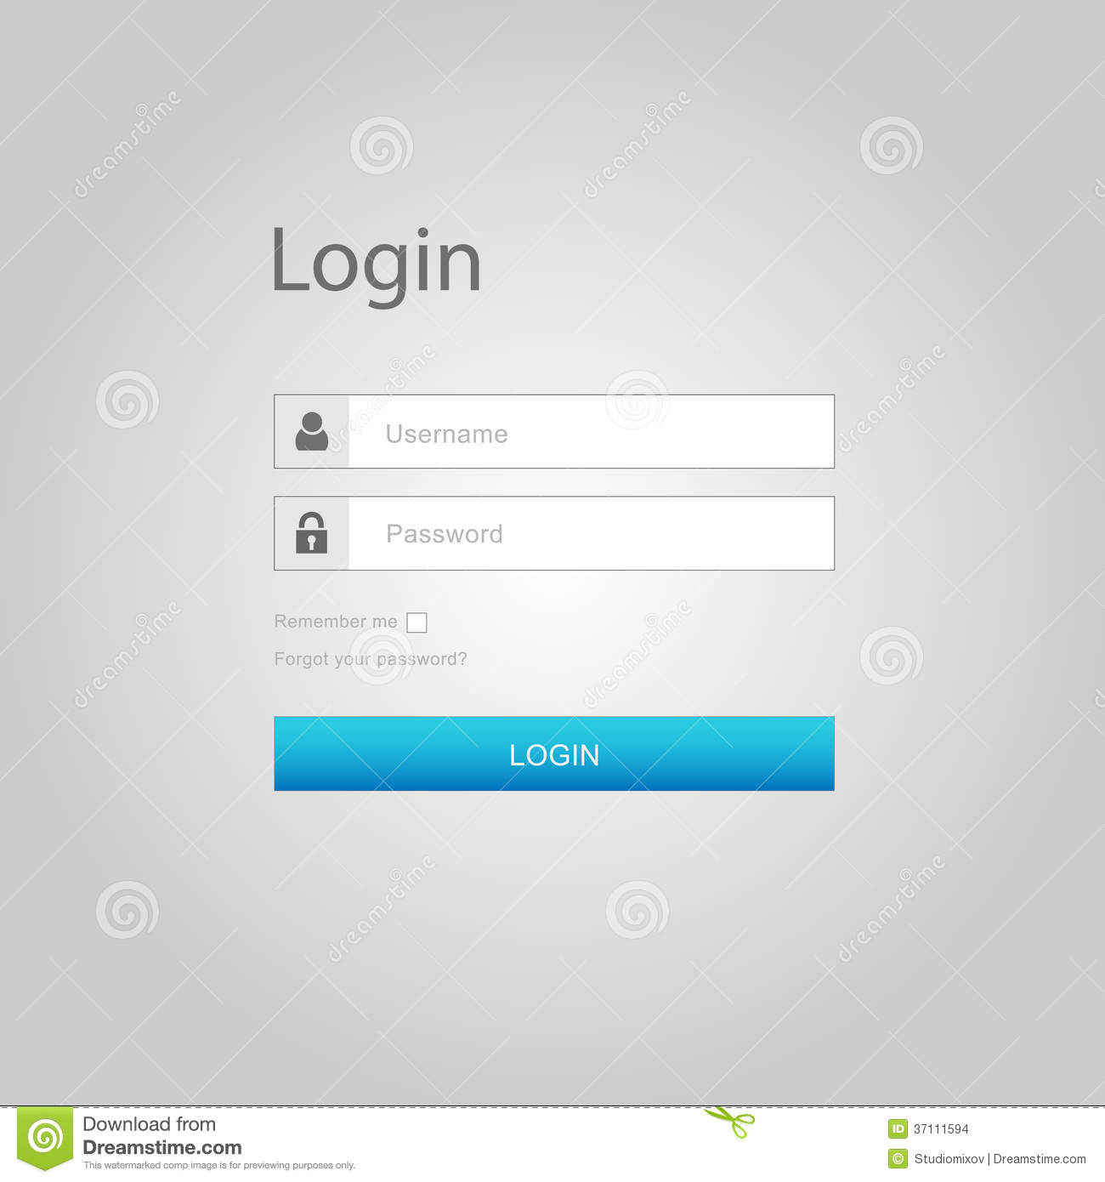

Home mortgage

Go to Home mortgage

Details to be filled

1. First name *
2. Middle name
3. Last name*
4. Primary address 1 *
5. Primary address 2
6. City *
7. State*
8. Country *
9. Zipcode*

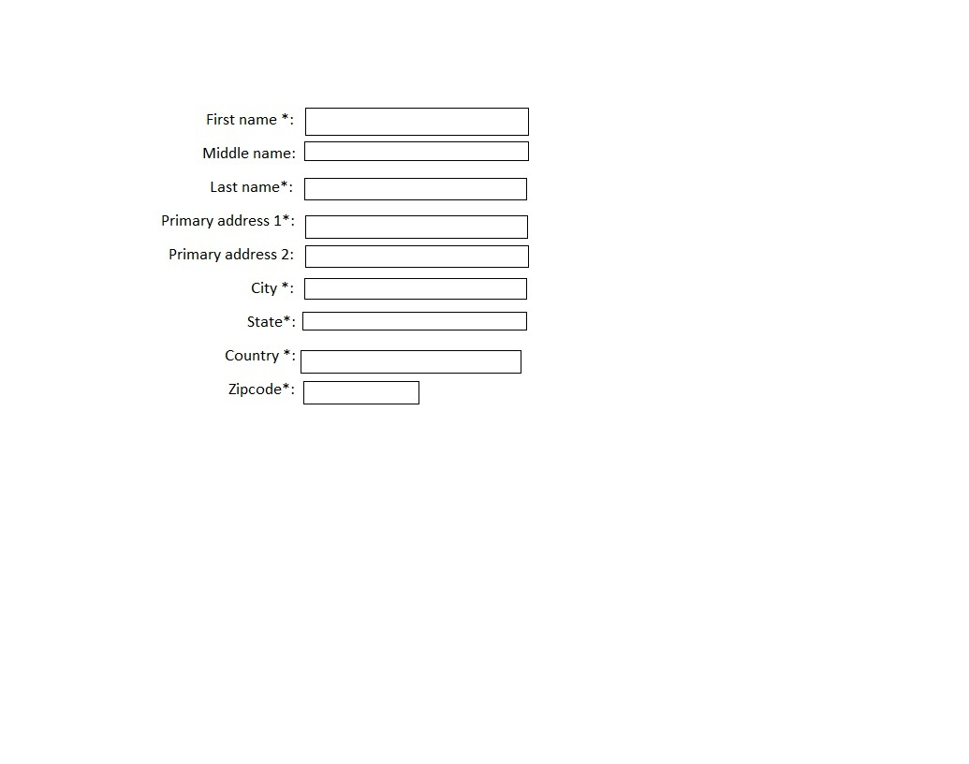

**Page2**

